**The DC Sniper Attacks**

[](https://www.google.com/url?sa=i&url=https://www.nydailynews.com/news/national/malvo-tells-today-show-sniper-molested-article-1.1191712&psig=AOvVaw2X46xLSr-NR51RjKZuDtk4&ust=1589298850438000&source=images&cd=vfe&ved=0CAIQjRxqFwoTCKi1qOaVrOkCFQAAAAAdAAAAABAD) 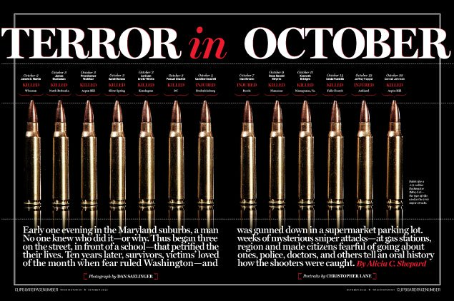

**What was it?**

The D.C. Sniper Attacks were a series of coordinated shootings that occurred during a three week time period in October of 2002. The attacks occurred in the District of Columbia, Maryland, and Virginia. Ten people were killed and three others were critically wounded by John Allen Muhammad and Lee Boyd Malvo.

**Directions:**

Research and explain how ballistics evidence was used to link the two suspects to the serial killings. Please summarize in an essay format. The response should be one and a half pages long.